First I ran both codes and did a dump to make sure everything was connected properly:
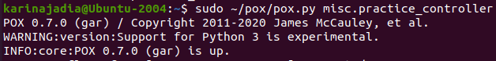
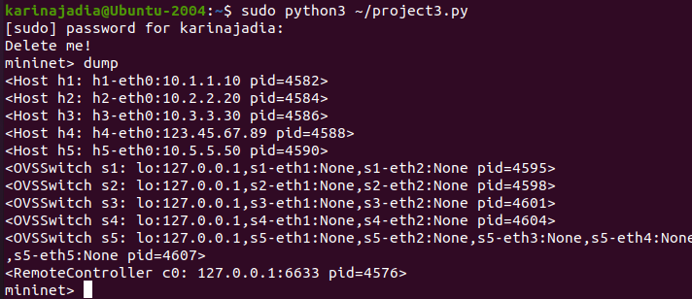

All of the hosts are connected to the correct IP address that I had configured, so the dump was successful!

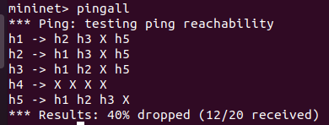
My pingall also showed the hosts connecting to each other. h4 cannot send IMCP packets to anyone because they are untrusted. All of the other hosts can ping each other.

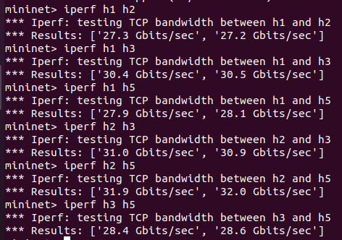
Here are the iperfs to see how each host interacts with each other. Unfortunately my h4 cannot send any traffic to the other hosts, when I try to run iperf it stalls forever and simply doesn’t work. I have all the rules and flow table set up in my controller so I don’t understand why it doesn’t work. The rest of the hosts can send data to each other.

I also did dpctl dump-flows to show how traffic moves between the hosts after a pingall.
